**HS Remixed Teen Literacy Team**

We can’t truly change high schools until we deal with this sad fact:

☹ Far too many teens cannot read, or read very poorly.

It affects every effort to rethink how high schools work.

HighSchoolRemixed believes that today’s teens can help change that for the teens of tomorrow.

Every child can learn to read. The scientific evidence shows us how to get there.

_______



**Products**

|  |  |
| --- | --- |
| [(Black) Teen Literacy Matters](https://docs.google.com/document/d/1cmw3UqX7Dio0qnjAAOIj53lcTPHESuryw6j9baSSr3I/edit?usp=sharing) high school industry credential. | [View this Open Source project on GitHub](https://github.com/High-School-Remixed/teen-literacy-matters) |
|  |  |

,

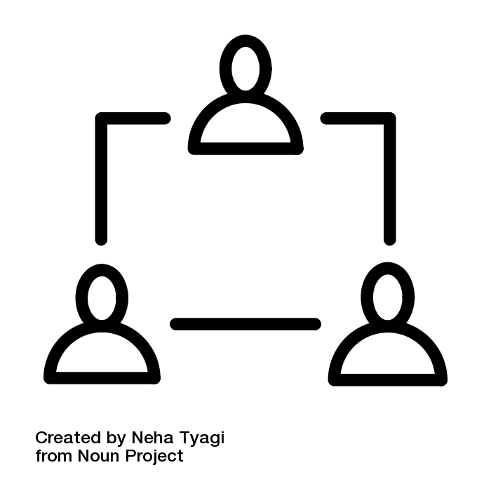

**Team**